**LAB MANUAL**

**of Subject**

**ESSENTIAL SKILLS OF INFORMATION TECHNOLOGY**

**Subject Code: 09CT0101**

**Student Name:** Khimsuriya Satya V.

**Enrollment No: 91900957041**

**Submission Date: 30/11/2019**

**Department of Information & Communication Technology**

**Faculty of Diploma Engineering**



**ESIT LAB - PRACTICAL INDEX**

|  |  |  |  |  |
| --- | --- | --- | --- | --- |
| **SR. NO.** | **TITLE** | **PAGE NO** | **DATE** | **SIGN** |
| 1 | HTML WEBSITE |  |  |  |
| 1.1 | Mainframe |  |  |  |
| 1.2 | Navigation |  |  |  |
| 1.3 | Header |  |  |  |
| 1.4 | Paragraphs |  |  |  |
| 1.5 | Lists |  |  |  |
| 1.6 | Tables |  |  |  |
| 1.7 | Tables Cell Padding & Spacing |  |  |  |
| 1.8 | Frames |  |  |  |
| 1.9 | Image & Link |  |  |  |
| 1.10 | Form |  |  |  |
|  |  |  |  |  |
| 2 | CSS |  |  |  |
| 2.1 | Selectors |  |  |  |
| 2.2 | Borders |  |  |  |
| 2.3 | Text |  |  |  |
| 2.4 | Fonts |  |  |  |
| 2.5 | Multiple Columns |  |  |  |
|  |  |  |  |  |
| 3 | DOCUMENTATION |  |  |  |
| 3.1 | Result Spreadsheet |  |  |  |
| 3.2 | Resume |  |  |  |
| 3.3 | Presentation |  |  |  |
| **SR. NO.** | **TITLE** | **PAGE NO** | **DATE** | **SIGN** |
| 4 | JAVASCRIPT |  |  |  |
|  |  |  |  |  |
| 5 | SoloLearn HTML Course Certificate |  |  |  |
|  |  |  |  |  |
| 6 | SoloLearn CSS Course Certificate |  |  |  |
|  |  |  |  |  |
| 7 | SoloLearn JavaScript Course Certificate |  |  |  |
|  |  |  |  |  |
| 8 | Spoken Tutorials Certificate - Introduction to Computers |  |  |  |

**STUDENT NAME: ________________________**

**STUDENT SIGN:**

**FACULTY SIGN HOD SIGN**

**PRACTICAL 1: HTML WEBSITE**

**Problem statement: Make a static website made in HTML.**

**Solution:**

**File Name: MainFrame.html**

**Code:**

**<html>**

**<frameset rows="25%,75%">**

**<frame src="Header.html"/>**

**<frameset cols="25%,75%">**

**<frame src="Navigation.html"/>**

**<frame src="" name="showframe"/>**

**</frameset>**

**</frameset>**

**</html>**

**Output:**

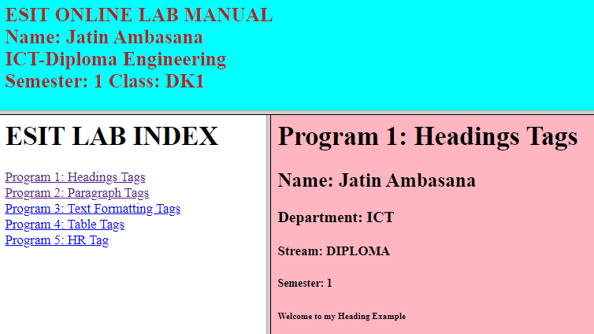

**File Name: Navigation.html**

**Code:**

**<html>**

**<body>**

**<h1> ESIT LAB INDEX</h1>**

**<a href="A.html" target="showframe"/>Program 1: Headings Tags</a>**

**<br/>**

**<a href="B.html" target="showframe"/>Program 2: Paragraph Tags</a>**

**<br/>**

**<a href="C.html" target="showframe"/>Program 3: Text Formatting Tags</a>**

**<br/>**

**<a href="D.html" target="showframe"/>Program 4: Table Tags</a>**

**<br/>**

**<a href="E.html" target="showframe"/>Program 5: Comment Tags</a>**

**<br/>**

**</body>**

**</html>**

**Output:**



**File Name: Header.html**

**Code:**

**<html>**

**<body bgcolor="skyblue" style="color:Brown">**

**<h2>ESIT ONLINE LAB MANUAL <br/>**

**Name: Khimsuriya Satya <br/>**

**ICT-Diploma Engineering <br/>**

**Semester: 1 Class: DK1**

**Roll No.:91900957041</h2>**

**</body>**

**</html>**

**Output:**



**File Name: Paragraphs.html**

**Code:**

**<html>**

**<body bgcolor="RED" style="color:YELLOW">**

**<h1>Program 2: Paragraph Tags</h1>**

**<h2>Name: Satya Khimsuriya</h2>**

**<p align="justify">This is my paragraph 1 in Program 2.</p>**

**<p align="center">This is my paragraph 2 in Program 2.</p>**

**<p align="right">Enrollment No: 91900957041</p>**

**<p align="right">Semester: 1</p>**

**<p align="right">Class: DK1</p>**

**<p align="right">Course: Diploma</p>**

**<p align="right">Department: ICT</p> </body>**

**</html>**

**Output:**

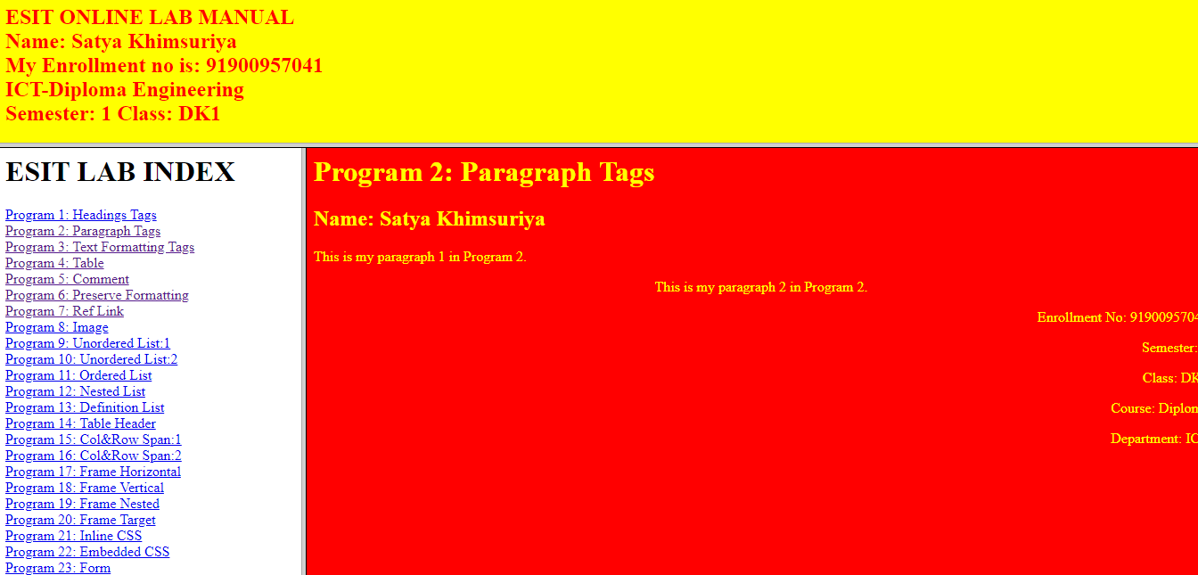

**File Name:** **Lists.html**

**Code:**

**<html>**

**<body><H1>Program 9: Unordered List:1</H1>**

**<h4>An Unordered List:</h4>**

**<ul>**

**<li>Coffee</li>**

**<li>Tea</li>**

**<li>Milk</li>**

**</ul>**

**</body>**

**</html>**

**Output:**

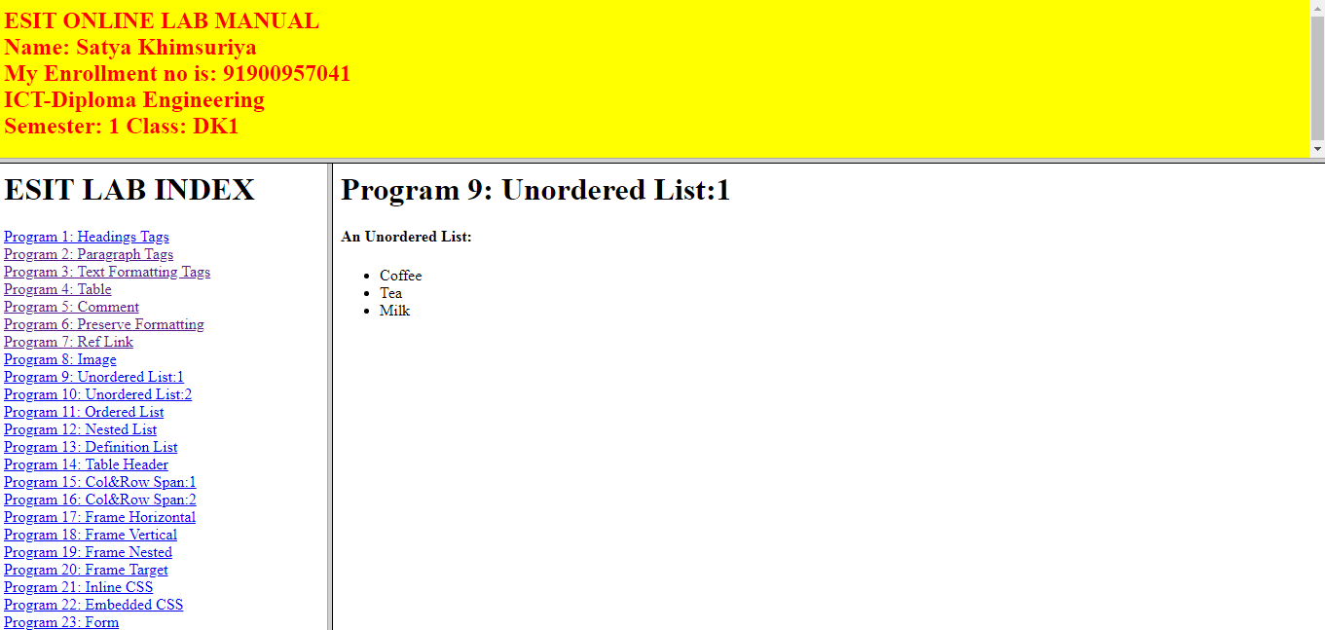

**File Name:** **Tables.html**

**Code:**

**<BODY>**

**<TABLE BORDER=”3”**

**BGCOLOR=”DARKYELLOW”>**

**<h1>Program 4: Table</h1>**

**<TR>**

**<TH>NAME</TH>**

**<TD BGCOLOR=”#C0C0C0”>KHIMSURIYA SATYA V.</TD>**

**</TR>**

**<TR>**

**<TH BGCOLOR=”#C0C0C0”>ROLL.NO.</TH>**

**<TD>91900957041</TD>**

**</TR>**

**<TR>**

**<TH>GR. NO.</TH>**

**<TD BGCOLOR=”#C0C0C0>107701</TD>**

**</TR>**

**<TR>**

**<TH BGCOLOR=”#C0C0C0>PHONE NO.</TH>**

**<TD>997 8574 214</TD>**

**</TR>**

**</TABLE>**

**</BODY>**

**Output:**

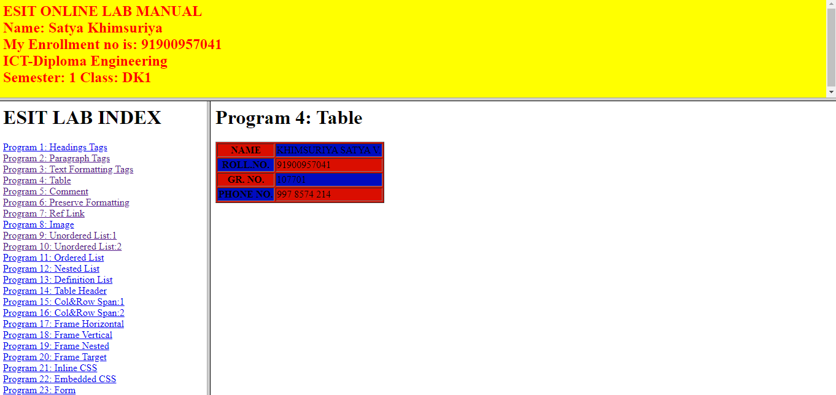

**File Name:** **Tables.html**

**Code:**

**<BODY>**

**<html>**

**<body>**

**<H1>Program 15: Rowspan and Colspan:1</H1>**

**<h4>Cell that spans two columns:</h4>**

**<table border="1">**

**<tr>**

**<th BGCOLOR=”#C0C0C0”>Name</th>**

**<th BGCOLOR=”#C0C0C0” colspan="2">Branch</th>**

**</tr>**

**<tr>**

**<td BGCOLOR=”red”>Satya</td>**

**<td BGCOLOR=”red”>ICT</td>**

**<td BGCOLOR=”red”>dk1</td>**

**</tr>**

**</table>**

**<h4>Cell that spans two rows:</h4>**

**<table border="1">**

**<tr>**

**<th BGCOLOR=”#C0C0C0”>Name</th>**

**<td BGCOLOR=”red”>Satya</td>**

**</tr>**

**<tr>**

**<th BGCOLOR=”#C0C0C0” rowspan="2">Branch</th>**

**<td BGCOLOR=”red”>ICT</td>**

**</tr>**

**<tr>**

**<td BGCOLOR=”red”>dk1</td>**

**</tr>**

**</table>**

**</body>**

**</html>**

**Output:**

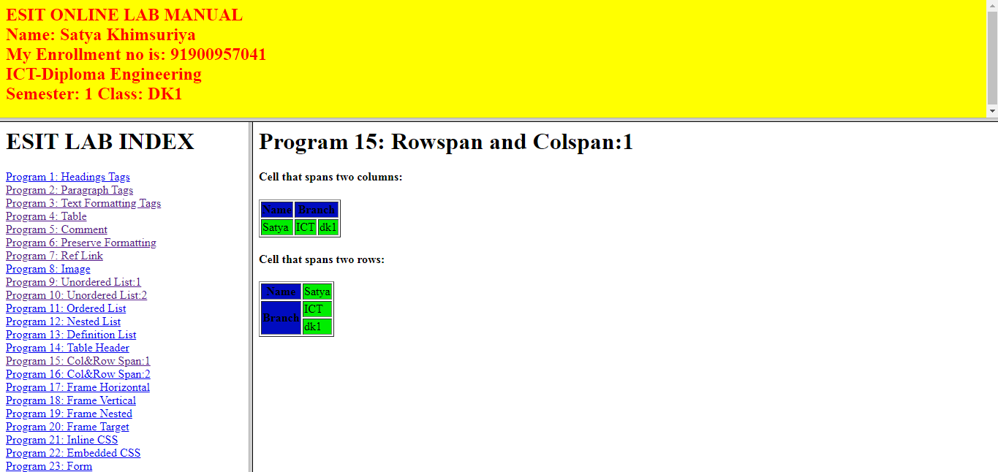

|  |
| --- |
|  |
|  |

**File Name:** **Frames and Image & Link.html**

**Code:**

**<html>**

**<frameset cols="30,70">**

**<frame src="1to3.html"/>**

**<frame src="1.HTML" name="showframe"/>**

**</frameset>**

**<noframes></noframes>**

**</html>**

**Output:**

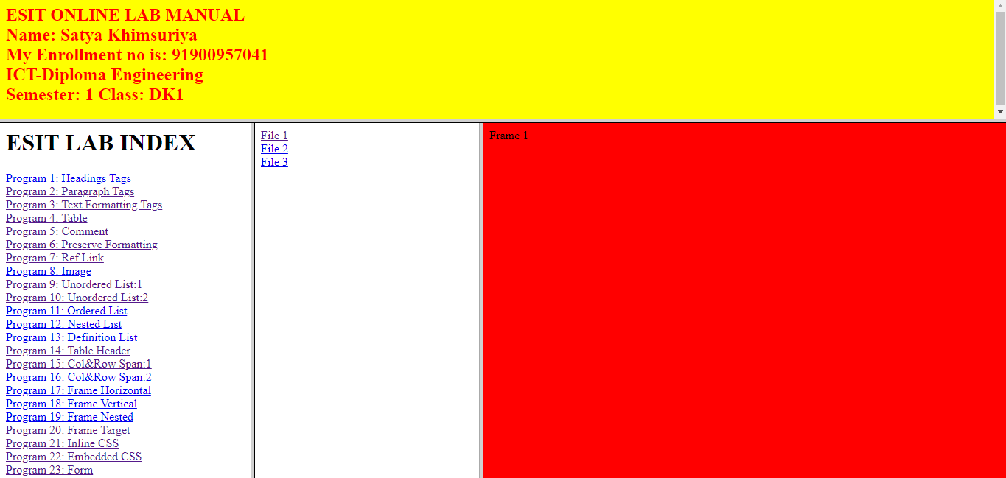

**File Name: Form.html**

**Code:**

**<html>**

**<body>**

**<center>**

**<form action="" method="GET">**

**<table border="1">**

**<tr>**

**<td> First Name: </td>**

**<td><input type="text" name="firstname"/></td>**

**</tr>**

**<tr>**

**<td> Last Name: </td>**

**<td><input type="text" name="lastname"/></td>**

**</tr>**

**<tr>**

**<td> Username: </td>**

**<td><input type="text" name="user"/></td>**

**</tr>**

**<tr>**

**<td> Password: </td>**

**<td><input type="password" name="password"/></td>**

**</tr>**

**<tr>**

**<td> Language : </td>**

**<td>**

**<input type="checkbox" name="lang" value="Guj"/>Gujarati**

**<input type="checkbox" name="lang" value="Hin"/>Hindi**

**<input type="checkbox" name="lang" value="Eng"/>English**

**</td>**

**</tr>**

**<tr>**

**<td> Gender: </td>**

**<td><input type="radio" name="sex" value="male"/>Male**

**<input type="radio" name="sex" value="female"/>Female**

**</td>**

**</tr>**

**<tr>**

**<td> City: </td>**

**<td>**

**<select name="city">**

**<option value="ahmedabad">Ahmedabad</option>**

**<option value="rajkot">Rajkot</option>**

**<option value="bhavnagar">Bhavnagar</option>**

**</select>**

**</td>**

**</tr>**

**<tr>**

**<td> Address: </td>**

**<td><textarea rows="5" cols="17"></textarea></td>**

**</tr>**

**<tr>**

**<td> Upload Photo: </td>**

**<td><input type="file"/></td>**

**</tr>**

**<tr>**

**<td></td>**

**<td><input type="submit" value="Register"/>**

**<input type="reset" value="Reset"></td>**

**</tr>**

**</table>**

**</form>**

**</center>**

**</body>**

**</html>**

**Output:**

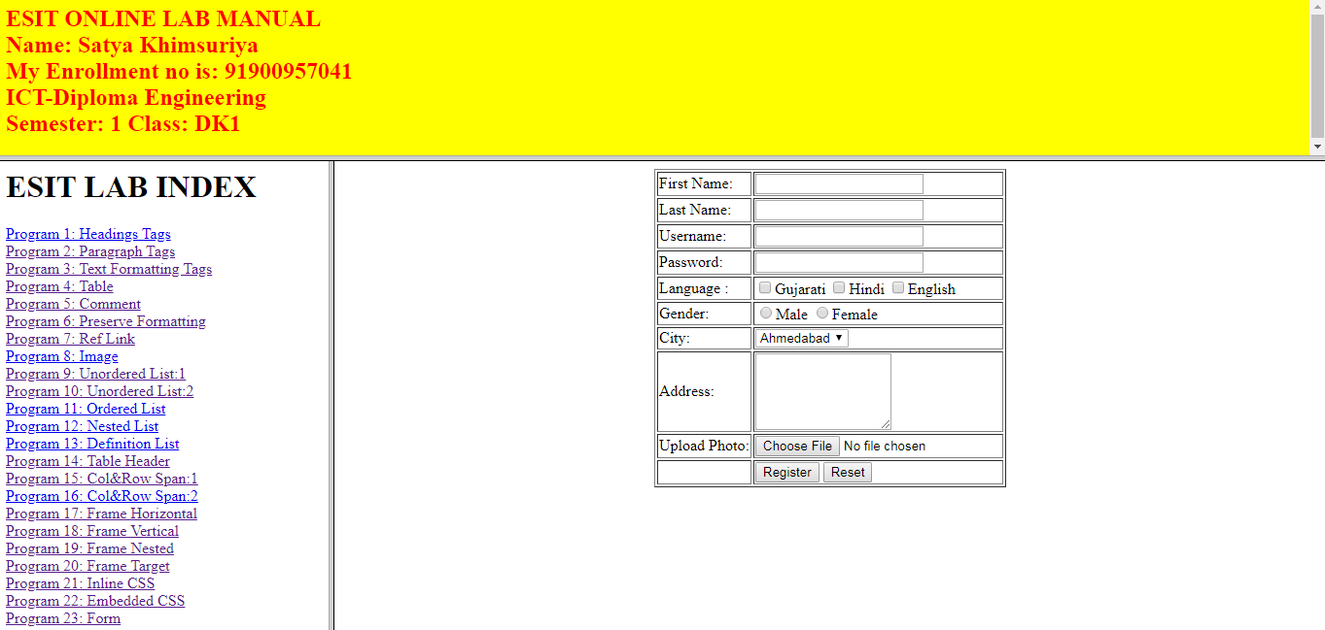

**PRACTICAL 2: CSS**

**File Name:** **Selectors.html**

**Code:**

<html>

<head>

<style>

body{

background-color:skyblue;

}

h1{

color:red;

text-align:left;

}

</style>

</head>

<body>

<h1>My First HTML File</h1>

<p>My First Paragraph.</p>

</body>

</html>

**Output:**



**File Name:** **Borders.html**

**Code:**

<!DOCTYPE html>

<html>

<head>

<title>css lab</title>

<style>

p.dotted {background-color: #239683;

border-color:#1AE17D;

border-style: dotted;}

p.dashed {border-style: solid;

border-color:#239683;

background-color: #1AE17D;

border-style: dashed;}

p.solid {border-style: solid;

background-color: #1AE1C0;

border-color: #4CE397 #4C76E3 #B073A4;

border-width: 4px 8px 5px 12px;}

p.double {border-style: double;

border-color: #239683 #1AE17D #1AE1C0 #94B073;

border-style: dotted dashed solid groove;

border-width: 6px 8px 8px 20px;

background-color: #69AD18;}

p.groove {border-style: groove;

border-color: #239683 #1AE17D;

background-color: #C53B4F;}

p.ridge {border-style: ridge;

border-radius: 10px

border : 15px #A1D04C;

background-color: lightblue}

p.mix {border-style: inset outset none hidden;

background-color: #1AE1C0;

border-color: #239683 #1AE17D #1AE1C0 #94B073;}

</style>

</head>

<body>

<p class="dotted">

ENROLMENT NO : 91900957041<br/>

NAME : Khimsuriya Satya<br/>

CLASS : DK1<br/>

BRANCH : I.C.T<br/>

SEM : 1<br/>

SUBJECT : ESIT<br/>

BORDER STYLE : DOTTED BORDER WITH BACKGROUND COLOR AND BORDER COLOR

</p>

<p class="dashed">

ENROLMENT NO : 91900957041<br/>

NAME : Khimsuriya Satya<br/>

CLASS : DK1<br/>

BRANCH : I.C.T<br/>

SEM : 1<br/>

SUBJECT : ESIT<br/>

BORDER STYLE : DASHED BORDER WITH BACKGROUND COLOR AND BORDER COLOR

</p>

<p class="solid">

ENROLMENT NO : 91900957041<br/>

NAME : Khimsuriya Satya<br/>

CLASS : DK1<br/>

BRANCH : I.C.T<br/>

SEM : 1<br/>

SUBJECT : ESIT<br/>

BORDER STYLE : SOLID BORDER WITH 1 BACKGROUND COLOR AND 3 BORDER COLOR

</p>

<p class="double">

ENROLMENT NO : 91900957041<br/>

NAME : Khimsuriya Satya<br/>

CLASS : DK1<br/>

BRANCH : I.C.T<br/>

SEM : 1<br/>

SUBJECT : ESIT<br/>

BORDER STYLE : SOLID BORDER WITH 1 BACKGROUND COLOR AND 3 BORDER COLOR

</p>

<p class="groove">

ENROLMENT NO : 91900957041<br/>

NAME : Khimsuriya Satya<br/>

CLASS : DK1<br/>

BRANCH : I.C.T<br/>

SEM : 1<br/>

SUBJECT : ESIT<br/>

BORDER STYLE : GROOVE BORDER WITH 1 BACKGROUND COLOR AND 2 BORDER COLOR

</p>

<p class="ridge">

ENROLMENT NO : 91900957041<br/>

NAME : Khimsuriya Satya<br/>

CLASS : DK1<br/>

BRANCH : I.C.T<br/>

SEM : 1<br/>

SUBJECT : ESIT<br/>

BORDER STYLE : RIDGE BORDER WITH 1 BACKGROUND COLOR AND 15PX BORDER RADIUS

</p>

<p class="mix">

ENROLMENT NO : 91900957041<br/>

NAME : Khimsuriya Satya<br/>

BRANCH : I.C.T<br/>

SEM : 1<br/>

SUBJECT : ESIT<br/>

BORDER STYLE : MIX BORDER WITH 1 BACKGROUND COLOR AND inset outset none hidden BORDER AND 4 BORDER COLOR

</p>

</body>

</html>

**Output:**

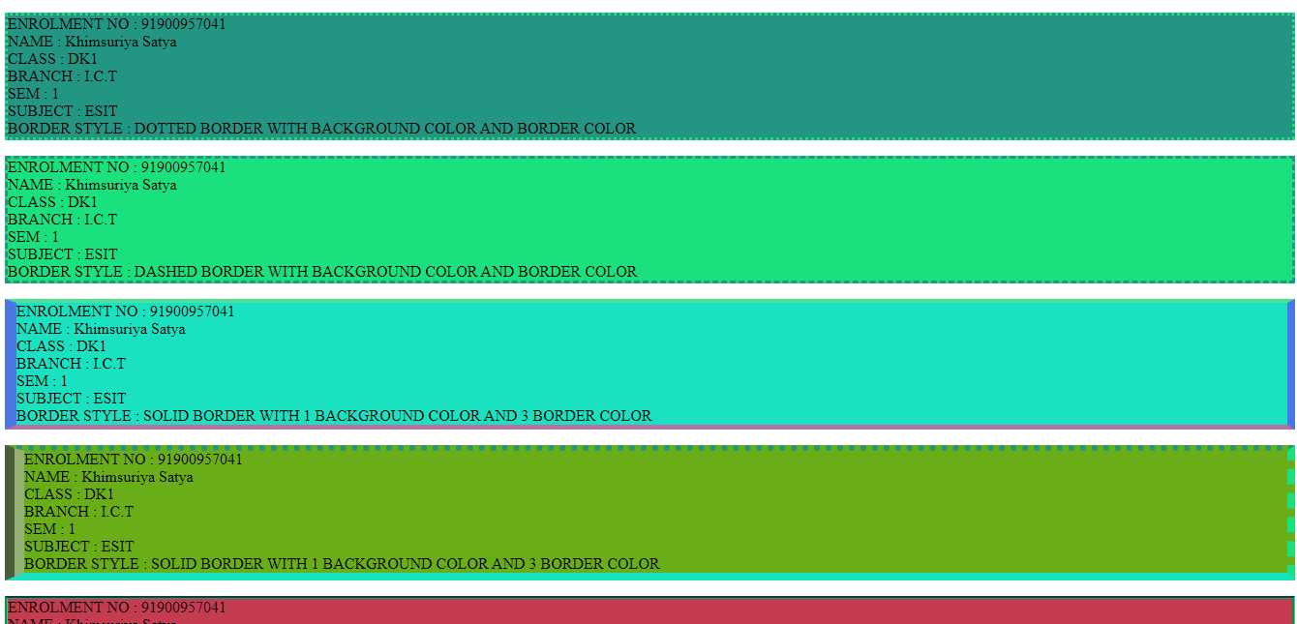

**File Name:** **Text.html**

**Code:**

<html>

<head>

<style>

body{

background-color:skyblue;

}

h1,h3,h5{

color:red;

text-align:left;

text-align:center;

}

h2,h4,h6{

text-align:left;

text-align:center;

</style>

</head>

<body>

<h1>This is heading 1</h1>

<h2>This is heading 2</h2>

<h3>This is heading 3</h3>

<h4>This is heading 4</h4>

<h5>This is heading 5</h5>

<h6>This is heading 6</h6>

</body>

</html>

**Output:**

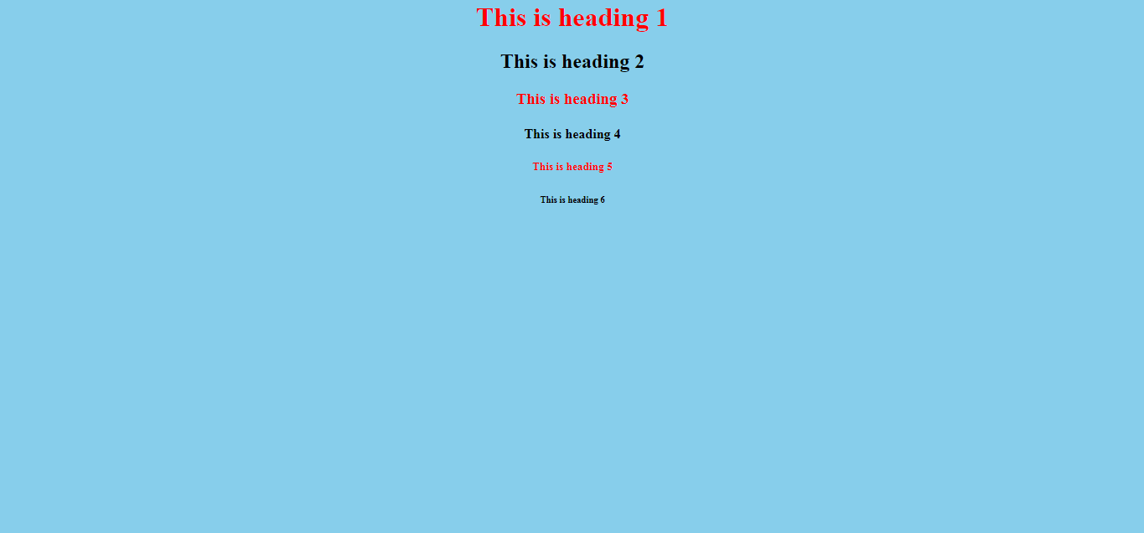

**File Name:** **Fonts.html**

**Code:**

<!DOCTYPE html>

<html>

<head>

<style>

p.serif {

font-family: "Times New Roman", Times, serif;

}

p.sansserif {

font-family: Arial, Helvetica, sans-serif;

}

p.sansserif1 {

font-family: Impact, Charcoal, sans-serif;

}

p.sansserif2 {

font-family: "Comic Sans MS", cursive, sans-serif;

}

p.normal {

font-style: normal;

}

p.italic {

font-style: italic;

}

p.oblique {

font-style: oblique;

}

h2 {

font-size: 30px;

}

h3 {

font-size: 20px;

}

p.1 {

font-size: 0.875em;

}

p.normal {

font-weight: normal;

}

p.light {

font-weight: lighter;

}

p.thick {

font-weight: bold;

}

p.thicker {

font-weight: 900;

}

p.normal {

font-variant: normal;

}

p.small {

font-variant: small-caps;

}

</style>

</head>

<body><div style="background: blue; color: red">

<h1 style="font-family:Lucida Sans Unicode, Lucida Grande, sans-serif">Name:Khimsuriya satya</h1>

<h1>Roll No:41</h1><hr/></div>

<h1 style="color: red; font-family:Courier New, Courier, monospace">CSS font-family</h1>

<div style="background: orange">

<p class="serif" style="color: red;">This is a paragraph, shown in the Times New Roman font.</p>

<p class="sansserif" style="color: white">This is a paragraph, shown in the Arial font.</p>

<p class="sansserif1" style="color: green">This is a paragraph, shown in the Impact font.</p>

<p class="sansserif2">This is a paragraph, shown in the Comic Sans MS font.</p><hr/></div>

<h1><P style="color: red;">CSS font-style</P></h1><div style="background: green">

<p class="normal" style="color: orange;">This is a paragraph in normal style.</p>

<p class="italic" style="color: white">This is a paragraph in italic style.</p>

<p class="oblique" style="color: red">This is a paragraph in oblique style.</p><hr/></div>

<h1><P style="color: orange">CSS font-Size</P></h1><div style="background: orange">

<h2 style="color: white">This is heading 1</h2>

<h3 style="color: green">This is heading 2</h3>

<hr/></div>

<h1><p style="color: red;">CSS font-Weight</p></h1><div style="background: green">

<p class="light" style="color: orange">This is a paragraph.</p>

<p class="thick" style="color: white">This is a paragraph.</p>

<p class="thicker" style="color: green">This is a paragraph.</p></div>

<h1 style="font-size:5vw;background-color: orange">Responsive Text</h1><hr>

<p><h1 style="color: red;">CSS font-Variant</h1></p><div style="background: green">

<p class="normal" style="color: white">My name is Hege Refsnes.</p>

<p class="small" style="color: red">My name is Hege Refsnes.</p></div>

</body>

</html> **Output:**

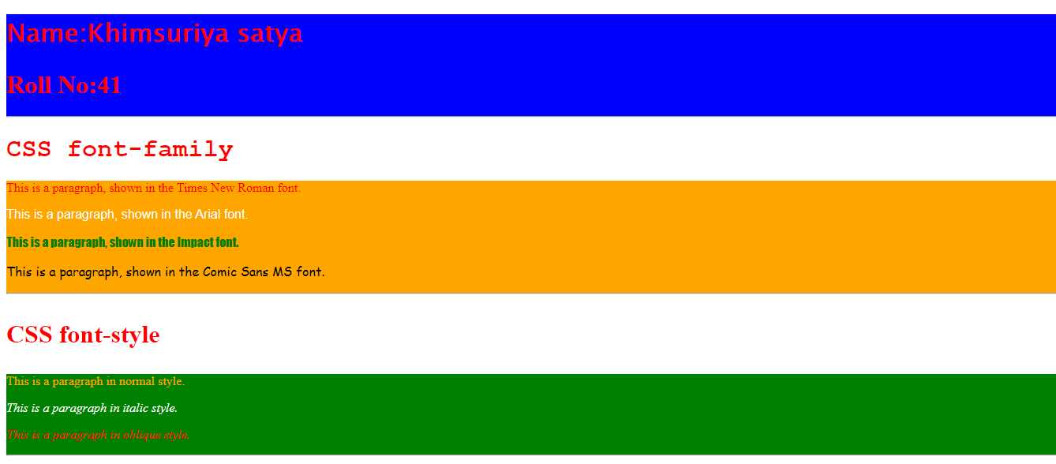

**File Name:** **MultipleColumns.html**

**Code:**

<!DOCTYPE html>

<html>

<head>

<style>

.newspaper {

-webkit-column-count: 3;

-webkit-column-gap: 40px;

-webkit-column-rule: 5px solid lightblue;

-moz-column-count: 3;

-moz-column-gap: 40px;

-moz-column-rule: 5px solid lightblue;

column-count: 3;

column-gap: 40px;

column-rule: 5px solid lightblue;

}

h2 {

-webkit-column-span: all;

column-span: all;

}

</style>

</head>

<body>

<p><h2><b>Note:</b>Indian Army</h2></p>

<div class="newspaper" style="background-color:grey;">

This article is about the Indian Army since 1947. For the earlier period, see Military history of India and British Indian ArmyThe Indian Army (Hindi: Bharatiya Thala Sena) is the land-based branch and the largest component of the Indian Armed Forces. The President of India is the Supreme Commander of the Indian Army,[6] and it is commanded by the Chief of Army Staff.(COAS), who is a four-star general. Two officers have been conferred with the rank of field marshal, a five-star rank, which is aceremonial position of great honour. The Indian Army originated from the armies of the East India Company, which eventually became the British Indian Army, and the armies of the princely states, which finally became the national army after independence. The units and regiments of the Indian Army have diverse histories and have participated in a number of battles and campaigns across the world, earning many battle and theatre honours before and after Independence.

</div>

</body>

</html>

**Output:**

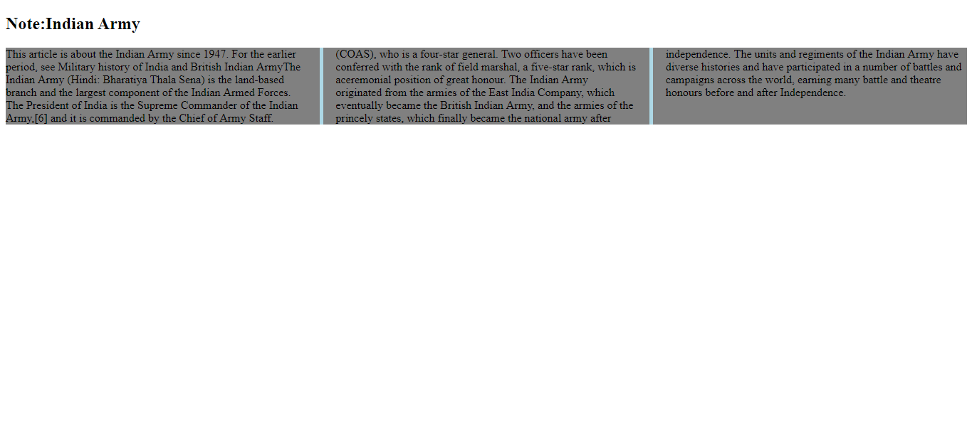

**SoloLearn HTML Course Certificate**



**SoloLearn CSS Course Certificate**

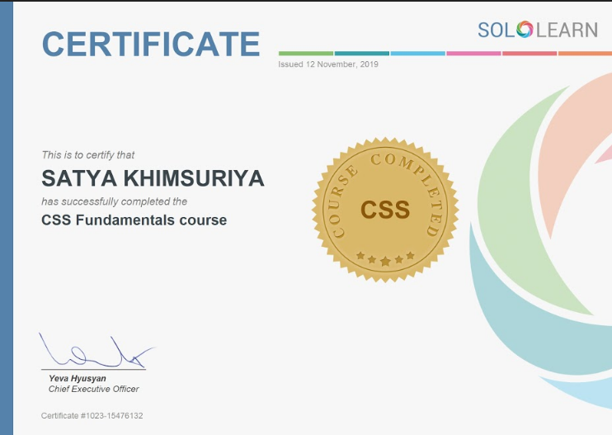

**SoloLearn JavaScript Course Certificate**

